Moniepoint Sales Network Optimization
Introducing Local Managers as an Intermediate Management Layer
Paul Bamidele | February 2026
Google Sheet: Sales_Network_Business_Case_Data_Analyst_Moniepoint
The Problem
Moniepoint's Sales Network has 95 State Coordinators(SC) and 7 Regional Managers(RM) overseeing 11,000 Business Relationship Managers(BRM) across Nigeria. This creates an unmanageable span of control each SC is indirectly responsible for over 100 BRMs, far exceeding the recognised management best practice of 8-25. Noticeable effects of these includes: coordination bottlenecks, limited coaching, and a network that cannot effectively scale.
The Proposal
Introduce 460 Local Managers as a new intermediate layer between State Coordinators and BRMs, funded entirely through a cost-neutral reallocation of the existing earnings pool.

- Each LM oversees 24 BRMs: within the optimal 8-25 span-of-control range
- LM compensation: ₦187,500/month: 25% above Nigeria's average salary of ₦150,000
- Total monthly LM cost: ₦86.25M, funded by reallocating 27.49% of the current ₦313.8M pool
- No incremental budget required: fully cost-neutral

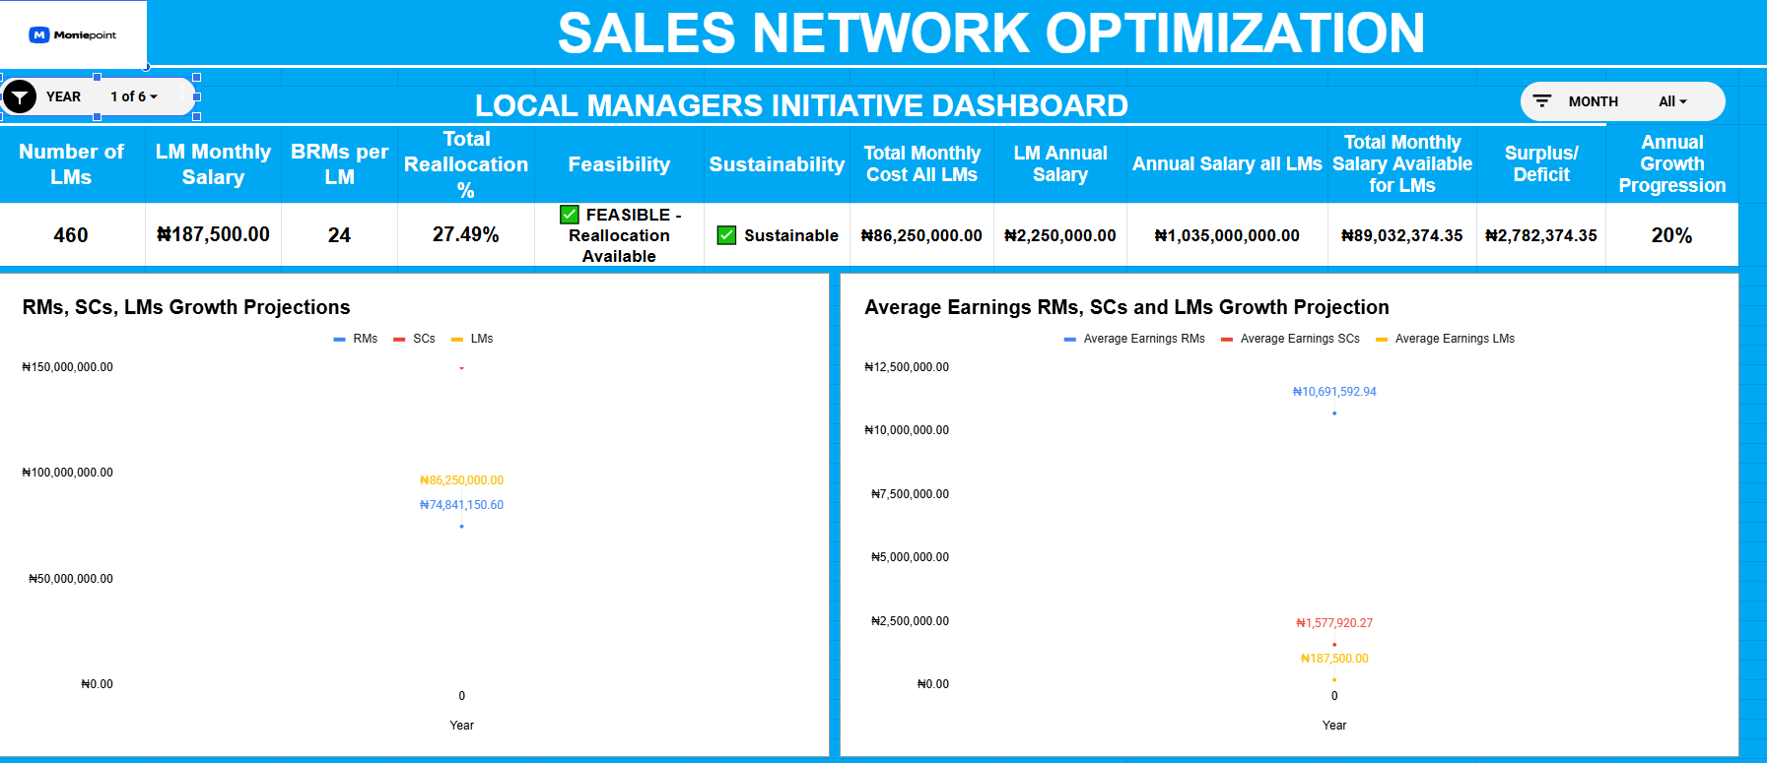
How Do We Get There? 12-Month Phased Rollout

Quarter | LMs Deployed | Objective
Q1 | 115 | Deploy in high-density regions to reduce SC workload and validate the initiative
Q2 | 230 | Expand coverage; assess early results and refine role definition
Q3 | 345 | Scale based on validated learnings; optimise regional distribution
Q4 | 460 | Complete national rollout; stabilise operations and embed reporting standards

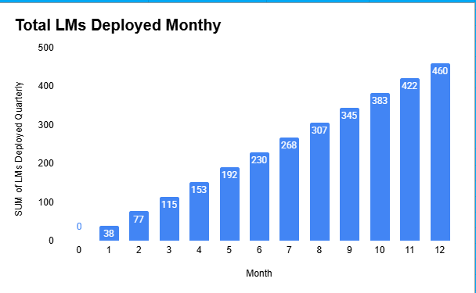

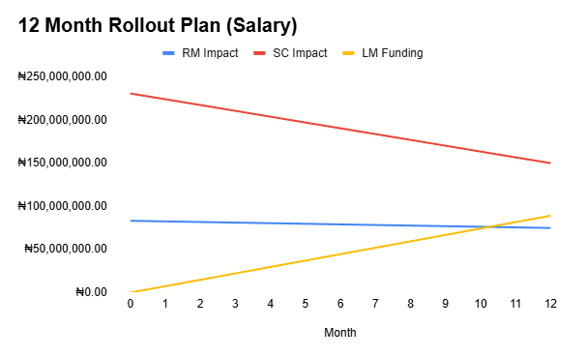
Financial Recovery
The earnings pool equals 2% of Moniepoint's global revenue and grows as the company grows. At a conservative 20% annual growth rate:

- Year 1: Pool grows to ₦373.1M; all roles benefit from expansion
- Year 2: Pool reaches ₦447.8M; Regional Managers exceed pre-LM earnings
- Year 3: Pool reaches ₦537.3M; State Coordinators exceed pre-LM earnings, full recovery achieved

At 15% growth, recovery takes 3-4 years. The variable compensation model ensures all parties benefit directly from Moniepoint's revenue growth.
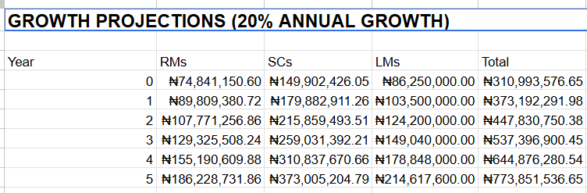

Recommendation & Way Forward
Proceed with the deployment of 460 Local Managers on a 12-month phased rollout. This initiative is cost-neutral, market-competitive in compensation, and directly solves a structural coordination gap that is limiting the network today.

- Approve the 27.49% reallocation of the SC/RM earnings pool to fund 460 LMs at ₦187,500/month
- Begin Q1 deployment of 115 LMs in the highest-density BRM regions immediately
- Establish a retention bonus framework for existing RMs and SCs to protect against short-term attrition
- Define clear LM KPIs (BRM onboarding rate, engagement score, retention) before Q1 launch
- Create an internal LM promotion pathway open to high-performing BRMs to drive buy-in across the network

Prepared by Paul Bamidele | February 2026 | Confidential

